**K-Means Clustering:** here k is the number of clusters. K is hyperparameter in K-Means clustering.

Geometrically what it does is, it finds centroid for each cluster.

Ex: it finds c1 from s1, c2 from s2 and c3 from s3.

Here no points of one cluster present in another, that means intersection of clusters set of points is null.

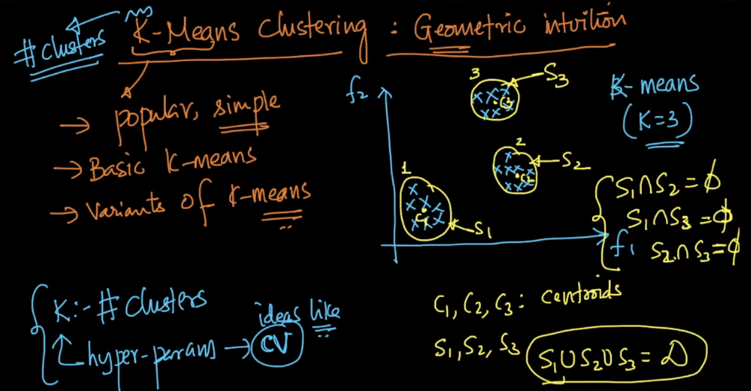

How centroid is find in each cluster is given below, it’s basically mean of all the points present in that cluster.

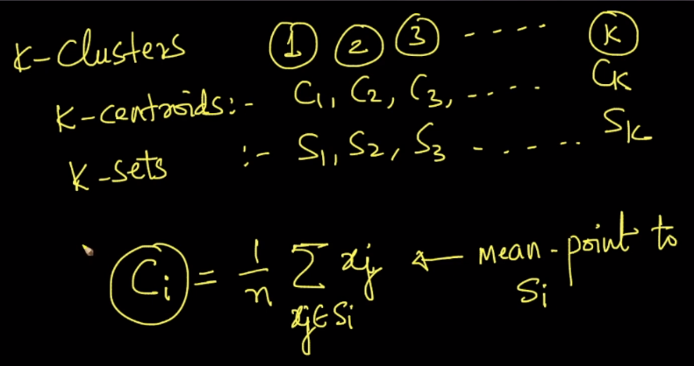

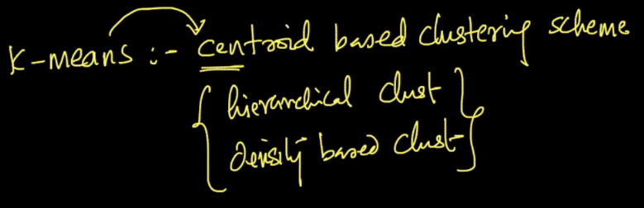

So after finding clustering if any new query point arrives, then it finds distance from all the centroids, which distance is minimum the point will be assigned to that cluster.

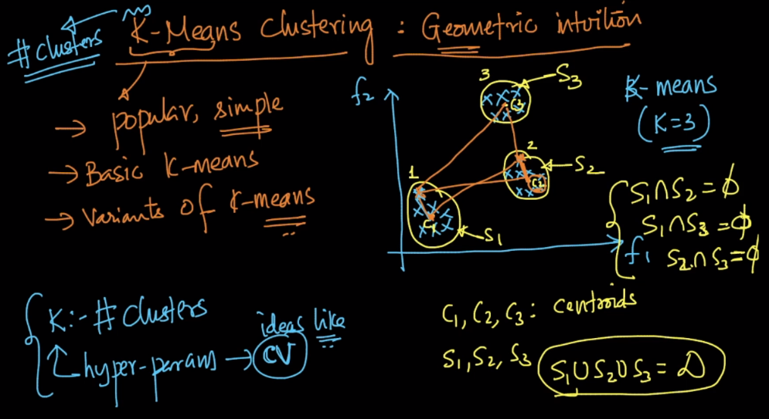

So all we need to find is the centroid in each cluster, there is a popular algo called Lloyd is used for finding centroids.

